Oblig 1

IKT

We can see that each.getDaysRented is called 6 times.  
We can make a variable x = each.getDaysRented and use this instead, to avoid calling the method that many times.  
  




We see that price codes are defined at final fields in Movie.java and used in the switch in Customer.java. We can move these to an abstract class, called MovieType.java, which will return the correct amount owed based on the (abstract) class. (Replace Conditional With Polymorphism)

We see now that the variable ‘pricecode’ is redundant, since we now use MovieType to differenciate them. So in Movie’s constructor, we now have an abstract ‘MovieType’ which can me polymorphed into Regular, New_release or childrens.   
  
This means that we can define different getPrice() methods in each of the abstract classes, and can move the method away from the switch-case from Customer.java (to MovieType).

**SLOC & McCabe's Cyclomatic Complexity**

SLOC before: 35 lines of code   
SLOC after: 22 lines of code

***M = E – N + 2P***

Cyclomatic complexity before:

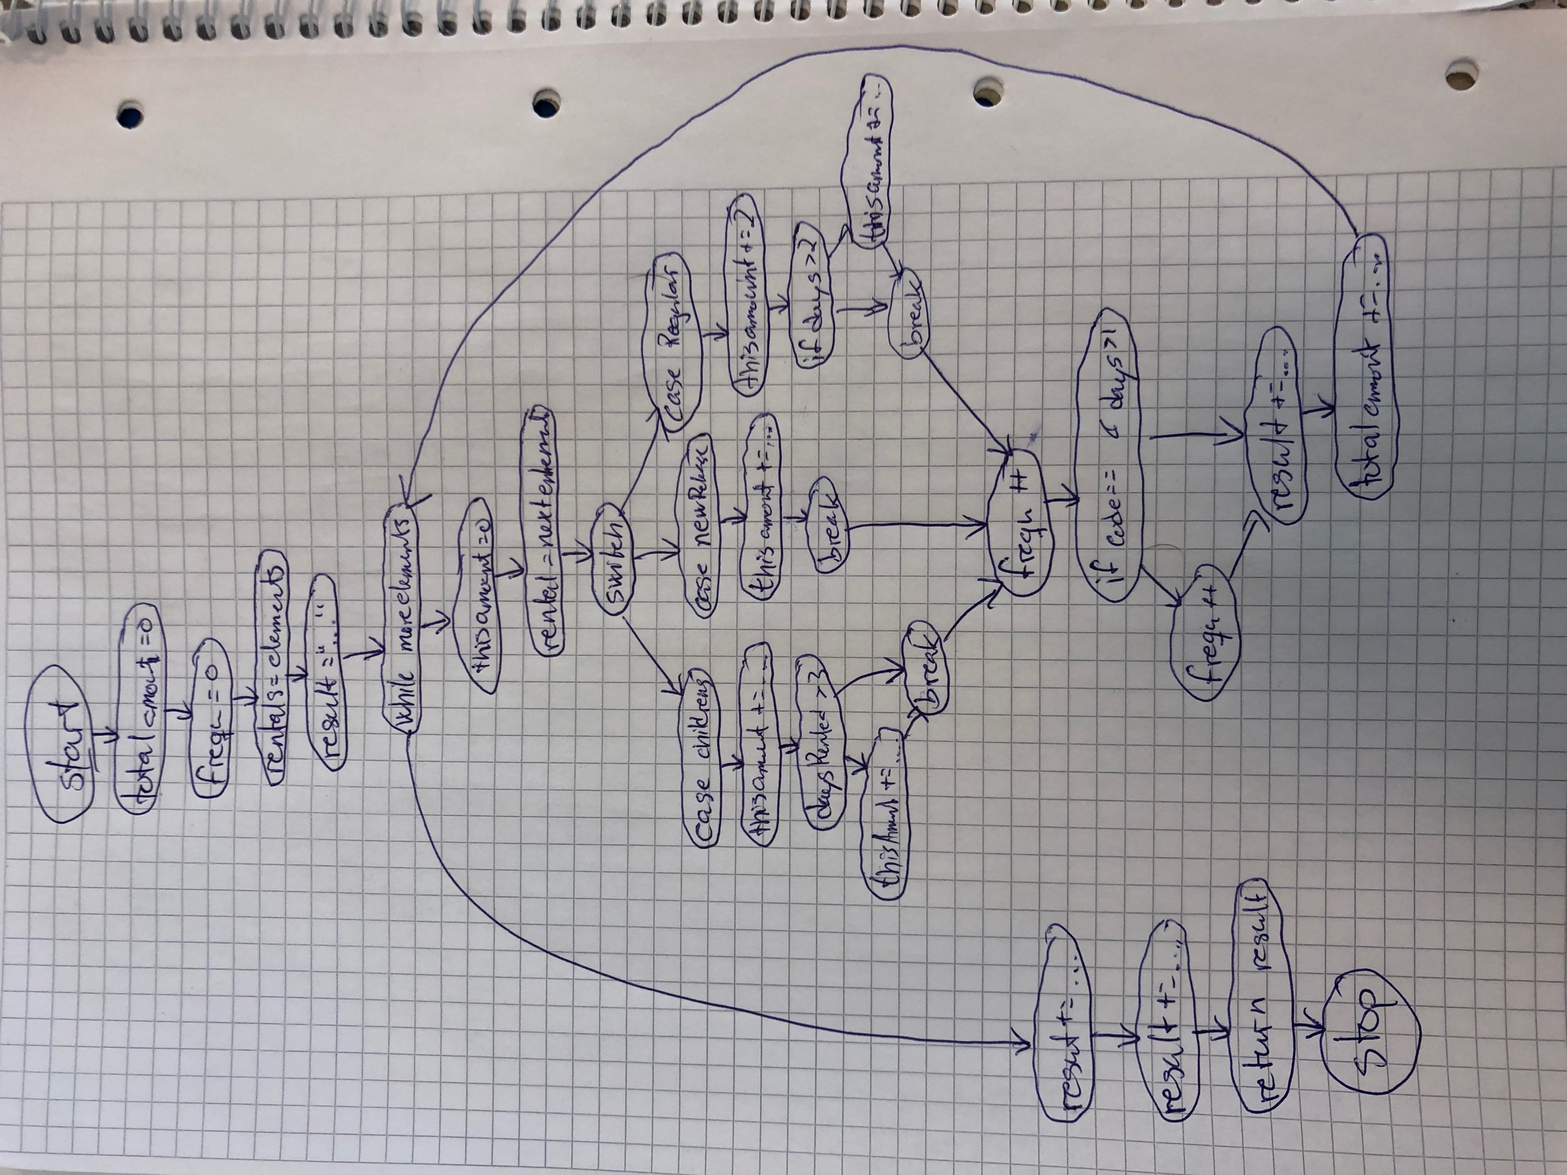

M = 36 - 31 + 2*1 = 7

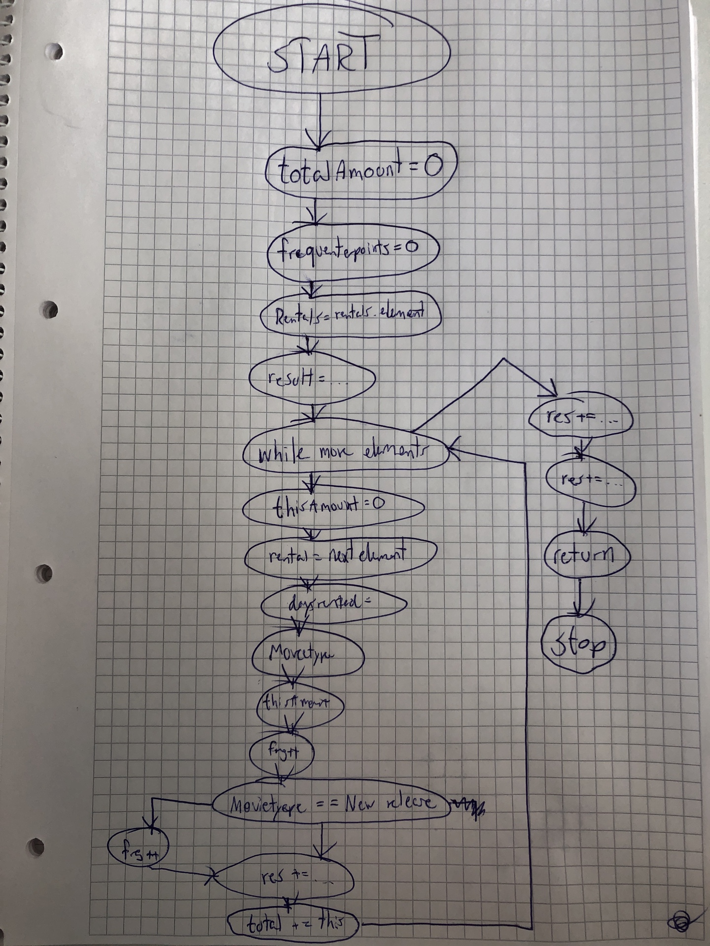

Cyclomatic complexity after:  
  
  
We have 21 edges and 20 nodes and 1 connected component.

That gives 21-20+2 = 3.

The refactoring that impacted the SLOC the most was moving the switch-statement to MovieType.java as a method (move method). This made the statement method do a lot fewer comparisons.

**Small, self-contained Java example**